


GUJARAT TECHNOLOGICAL UNIVERSITY

ROLE BASED FASHION BUSINESS CRM

A PROJECT REPORT

Submitted by Leezaba Solanki [231253107024]
Patel Kajal Sureshbhai [231253107039]

In partial fulfillment for the award of the degree of

BACHELOR OF ENGINEERING
in

COMPUTER ENGINEERING

SWAMINARAYAN INSTITUDE OF TECHNOLOGY,
GANDHINAGAR

Gujarat Technological University, Ahmedabad April - 20206

SHREE SWAMINARAYAN INSTITUDE OF TECHNOLOGY
Gandhinagar, Bhat

CERTIFICATE

This is to certify that the project report submitted along with the project entitled “Role Based Fashion Business CRM” has been carried out by Leezaba Solanki under my guidance in partial fulfillment for the degree of Bachelor of Engineering in Department of computer
engineering,8th Semester of Gujarat Technological University, Ahmadabad during the

academic year 2026-2027.




Dr. Darshan Poonambhai Patel
Internal Guide

Dr. Darshan Poonambhai Patel
Head of the Department

SHREE SWAMINARAYAN INSTITUDE OF TECHNOLOGY
Gandhinagar, Bhat

CERTIFICATE

This is to certify that the project report submitted along with the project entitled “Role Based Fashion Business CRM” has been carried out by Patel Kajal Sureshbhai under my guidance in partial fulfillment for the degree of Bachelor of Engineering in Department of Computer
Engineering, 8th Semester of Gujarat Technological University, Ahmadabad during the

academic year 2026-2027.


Dr. Darshan Poonambhai Patel
Internal Guide

Dr. Darshan Poonambhai Patel
Head of the Department

SHREE SWAMINARAYAN INSTITUTE OF TECHNOLOGY
NearAgoraMall&EDICampus,Bhat,Gandhinagar - 382428

DECLARATION
We hereby declare that the Internship / Project report submitted along with the Internship / Project entitled Role-Based Fashion Business CRM submitted in partial fulfillment for the degree of Bachelor of Engineering in Computer Engineering to Gujarat Technological University, Ahmedabad, is a bonafide record of original project work carried out by me / us at Tech Creature Solution under the supervision of Prof.Niraj Thakor and that no part of this report has been directly copied from any students’ reports or taken from any other source, without providing due reference.

Name of the Student
- Leezaba Solanki
- Patel Kajal Sureshbhai
Sign of Student

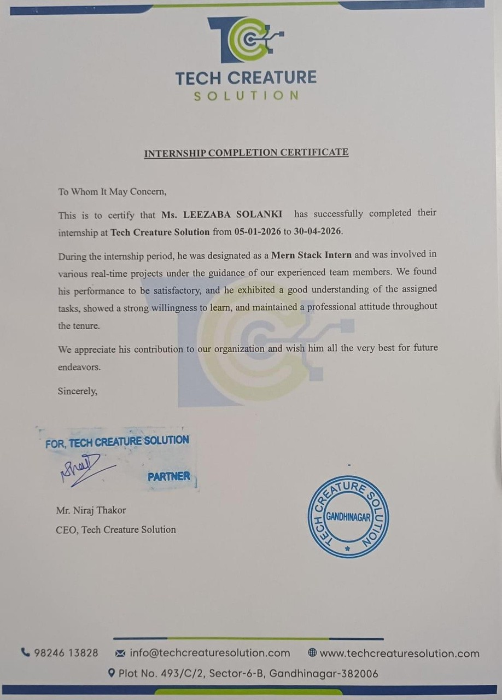




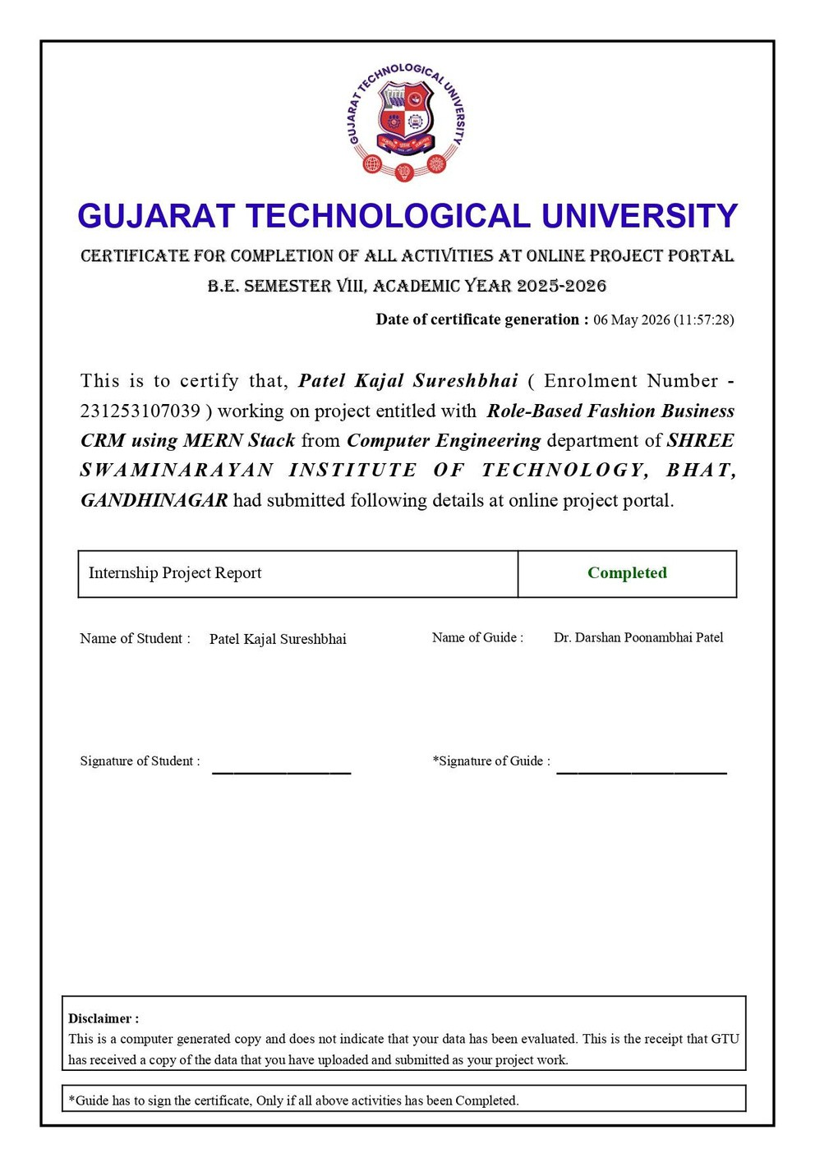

List of Figures
Fig 1.1 System Architecture of Fashion Clothing CRM 3
Fig 1.2 Overall Fashion Business CRM Workflow 6
Fig 2.1 System Analysis Of Fashion CRM 11
Fig 2.2 Workflow Of Customer 14
Fig 2.3 Working Process Of CRM 16
Fig 3.1 Workflow Of Processing After Designing 18
Fig 4.1 System activities 27
Fig 4.2 Proposed System 30
Fig 4.3 End-To-End Lifecycle 30

List of Screenshots

Screenshot 1.1 Login Page for User and Admin Screenshot 1.2 Home Page
Screenshot 1.3 User Registration Page Screenshot 1.4 Admin Dashboard

ABBREVATIONS

List of Abbrevations
MERN – MongoDB, Express.js, React.js, Node.js
JS – JavaScript
ES6 – ECMAScript 2015 (modern JavaScript version) Node.js – JavaScript Runtime Environment Express.js – Backend Web Application Framework React.js – Frontend JavaScript Library
MongoDB – NoSQL Database
Mongoose – MongoDB Object Data Modeling Library
API – Application Programming Interface REST – Representational State Transfer HTTP – HyperText Transfer Protocol
HTTPS – HyperText Transfer Protocol Secure
URL – Uniform Resource Locator JSON – JavaScript Object Notation JWT – JSON Web Token
Auth – Authentication
OAuth – Open Authorization
CRUD – Create, Read, Update, Delete
MVC – Model View Controller SPA – Single Page Application DOM – Document Object Model ODM – Object Data Modeling DOC – Document Verification
ADM-APP – Admission Application
UID – Unique Identification
DBMS – Database Management System
Git – Version Control System GitHub – Code Hosting Platform NPM – Node Package Manager

Table of Contents
Acknowledgement I
Abstract II
Chapter 1 Introduction ..................................................................................................
  - Introduction to Topic 1
    - Overview Of System 4
    - The Concept Of Fashion CRM 4
    - Digital Transformation 5
  - Problem Statement 5
  - Objectives Of The Project 6
  - Scope Of Project 8
Chapter 2 Literature Review and System Analysis ........................................................
  - Introduction to Topic 12
    - Study of Existing Manual Method 15
Chapter 3 Project Management ......................................................................................
  - Introduction to Methodology 19
    - Selection of Development Methodology 22
  - Project Planning 24
Chapter 4 System Design................................................................................................
  - Introduction 26
  - System Architecture 28
  - Database Design 29
Chapter 5 Implementation & Testing ..........................................................................
  - Introduction 31
  - Tools & Technologies 31
  - Module Description 31
  - Testing & Results 32


Chapter 6 Result & Discussion ..........................................................................................

Chapter 7 Conclusion.......................................................................................................
Chapter 8 Future Scope ...................................................................................................
References 37
Appendix 38

Acknowledgement

Iwould like to express my sincere gratitude and heartfelt appreciation to all those who contributed directly and indirectly to the successful completion of the project titled “Role-Based Fashion Business CRM System.”

First and foremost, I express my deepest thanks to my respected project guide, Dr. Darshan Poonambhai Patel, for his continuous guidance, valuable suggestions, encouragement, and technical support throughout the development of this project. His expert advice and motivation helped me understand practical software development concepts and successfully complete the project work.

I would also like to thank the Head of the Department and all faculty members of the Information Technology Department, Shree Swaminarayan Institute of Technology, Gandhinagar, for providing the necessary academic support, facilities, and positive learning environment required during the project development process.

I extend my sincere appreciation to Gujarat Technological University (GTU) for providing the academic framework and opportunity to work on this project as a part of the Bachelor of Engineering curriculum.

Special thanks to my friends and classmates for their valuable suggestions, teamwork, and constant support during different phases of project implementation and testing. Their cooperation helped me overcome many technical challenges successfully.

I would also like to express my gratitude to the organization and online learning resources that provided technical knowledge and development guidance related to MERN Stack technologies used in this project.

Finally, I express my deepest gratitude to my parents and family members for their unconditional love, encouragement, patience, and continuous moral support throughout my academic journey. Their belief in me has always been the greatest source of inspiration and strength.

I sincerely thank everyone who contributed to the successful completion of this project.

I

Abstract

The rapid growth of the fashion retail industry and increasing customer expectations have created a strong need for efficient business management systems capable of handling customer interactions, inventory management, and sales operations in an organized manner. Traditional methods such as manual record keeping, spreadsheets, and isolated software applications often result in operational inefficiencies, data redundancy, delayed communication, and poor customer relationship management. To overcome these challenges, the “Role-Based Fashion Business Customer Relationship Management (CRM)” system is developed as a web-based application that automates and integrates major business activities into a centralized digital platform.

The primary objective of the proposed system is to improve customer relationship management and streamline operational workflows within fashion clothing businesses. The application enables organizations to maintain customer information, manage clothing products and inventory, process orders, monitor sales activities, and generate business reports efficiently. The system follows a role-based access mechanism where administrators and employees are provided with different permissions according to their responsibilities, ensuring secure and controlled access to business data.

The project is developed using MERN Stack technologies, including MongoDB for database management, Express.js and Node.js for backend server-side development, and React.js for designing a responsive and interactive user interface. RESTful APIs are implemented to establish secure communication between frontend and backend components. The system architecture ensures scalability, flexibility, high performance, and efficient handling of real-time business operations.

The CRM application provides multiple features such as secure user authentication, customer registration, product management, order tracking, inventory monitoring, dashboard analytics, and report generation. By automating daily business activities, the system reduces manual workload, minimizes errors, improves operational transparency, and enhances customer satisfaction. Real-time data availability enables management to analyze customer behavior, monitor sales performance, and make informed business decisions.

Furthermore, the system supports digital transformation in the fashion retail industry by replacing traditional business processes with a modern technology-driven solution. The modular and scalable design allows future enhancements such as mobile application integration, cloud deployment, online payment systems, and artificial intelligence-based customer recommendations.

In conclusion, the Role-Based Fashion Business CRM system demonstrates the practical implementation of modern web development technologies in solving real-world business problems. The project provides an efficient, secure, and user-friendly platform that improves customer engagement, operational management, and overall business productivity within the fashion industry.

II

Chapter 1 Introduction

Introduction To Topic

The rapid growth of digital technology has significantly transformed the way modern businesses operate and manage customer interactions. In today’s competitive market environment, organizations are increasingly adopting automated systems to improve efficiency, enhance customer satisfaction, and streamline business operations. Among various industries, the fashion clothing sector is one of the fastest-growing and highly customer-oriented industries maintaining strong customer relationships and managing dynamic product inventories are essential for business success. Traditional business management methods such as manual record keeping, spreadsheets, and disconnected software systems are no longer sufficient to meet the growing demands of modern fashion retail businesses.

Customer Relationship Management (CRM) is a technology-driven approach that helps organizations manage customer information, track interactions, analyze purchasing behavior, and improve communication between businesses and customers. A CRM system enables businesses to maintain organized customer records, automate workflows, monitor sales activities, and provide personalized services that enhance customer loyalty and satisfaction. In the fashion clothing industry, where customer preferences and market trends change rapidly, an efficient CRM system plays a vital role in improving operational management and supporting business growth.

The “Role-Based Fashion Business CRM” project is developed to provide a centralized web-based platform for managing customers, clothing products, inventory, orders, and sales operations within a fashion retail environment. The system is designed to automate daily business activities and reduce the limitations associated with manual management processes. It allows administrators and employees to access different functionalities according to their roles, ensuring secure and efficient handling of business operations. By integrating customer management with inventory tracking and sales monitoring, the system improves data accuracy, operational transparency, and decision-making capabilities.

The project is implemented using modern MERN Stack technologies, including MongoDB for database management, Express.js and Node.js for backend server development, and React.js for creating an interactive and responsive user interface. The application follows a client-server architecture where frontend and backend components communicate through RESTful APIs to ensure smooth and secure data exchange. The system provides features such as customer registration, product management, order processing, inventory control, dashboard monitoring, and report generation.

1

The main purpose of developing this project is to replace traditional business processes with a modern digital solution that improves productivity, minimizes manual errors, and enhances customer engagement. The CRM system also helps fashion businesses analyze customer behavior, monitor product performance, and generate business insights that support strategic planning and growth. Additionally, the role-based access mechanism ensures secure management of sensitive business data while improving workflow coordination among employees.

2

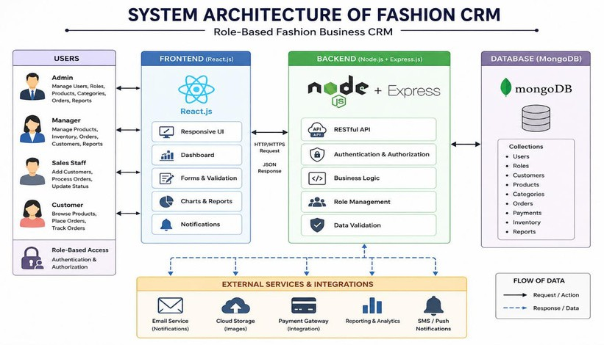
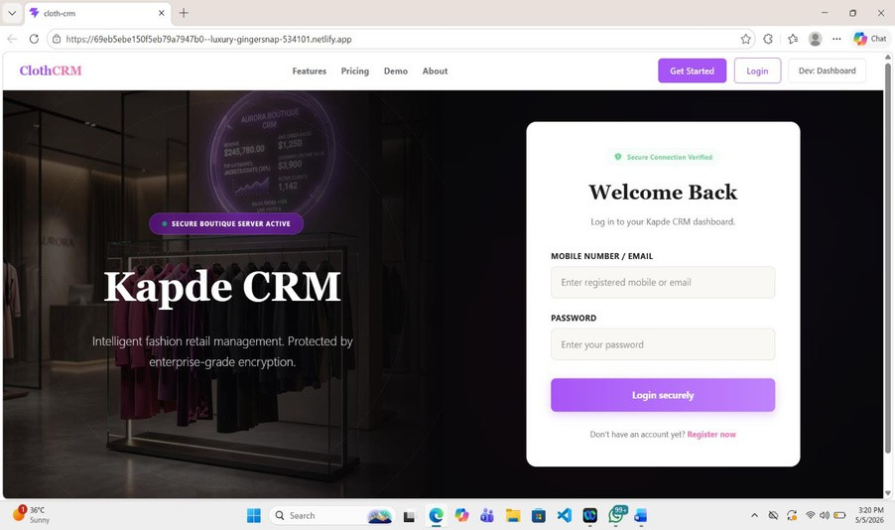
Figure 1.1: System Architecture Of Fashion CRM

Screenshot 1.1 Login Page for User and Admin

3

Overview of Systems

The Role-Based Fashion Business Customer Relationship Management (CRM) system is a web-based application developed to automate and manage business operations within the fashion clothing industry. The system provides a centralized platform for handling customer information, product inventory, sales transactions, order management, and business reporting efficiently. It enables administrators and staff members to access functionalities based on their roles through secure authentication mechanisms, ensuring proper management and protection of business data. Developed using MERN Stack technologies such as MongoDB, Express.js, React.js, and Node.js, the system offers a responsive user interface, real-time data processing, and smooth communication between frontend and backend components through RESTful APIs. The CRM system helps businesses improve customer relationships, reduce manual work, enhance operational efficiency, monitor inventory and sales performance, and support data-driven decision making, while also providing scalability for future enhancements such as mobile integration, cloud deployment, and AI-based features.

Manual Paper-Based Systems
A manual paper-based system is a traditional method of managing business operations where customer records, inventory details, sales transactions, and billing information are maintained using physical documents, registers, and files. In fashion clothing businesses, this system is time-consuming, difficult to manage, and prone to human errors such as duplicate entries, missing records, and incorrect calculations. It also lacks centralized data management, real-time updates, and secure storage, making it difficult for businesses to track customer information, manage inventory efficiently, and generate accurate reports. Due to these limitations, manual systems reduce operational efficiency and customer satisfaction, creating the need for an automated CRM solution.

The Concept of Fashion CRM

Fashion Customer Relationship Management (Fashion CRM) is a digital business management system designed specifically for the fashion and clothing industry to manage customer interactions, sales activities, inventory, and business operations efficiently. The main concept of Fashion CRM is to build strong relationships between fashion businesses and customers by collecting, organizing, and analyzing customer information such as purchase history, preferences, feedback, and communication records.

In the fashion industry, customer satisfaction and personalized shopping experiences are very important for business growth and brand loyalty. Fashion CRM helps businesses understand customer behavior, manage clothing products and inventory, track orders and sales, and improve communication with customers through a centralized platform. The system automates daily operations such as customer registration, billing, inventory updates, and report generation, reducing manual work and improving accuracy.

A Fashion CRM system also supports role-based management where administrators, managers, and staff members can access different functionalities according to their responsibilities.

4

Digital Transformation

Digital transformation refers to the process of using modern digital technologies to improve and automate business operations, customer services, and organizational processes. It involves replacing traditional manual methods with technology-driven solutions that increase efficiency, accuracy, productivity, and customer satisfaction. In today’s competitive business environment, digital transformation helps organizations adapt to changing market demands and improve decision-making through real-time data and automation.

In the fashion clothing industry, digital transformation plays an important role in managing customer relationships, inventory, sales, and business communication more effectively. Traditional paper- based systems and manual processes are being replaced by web applications, cloud platforms, online management systems, and automated CRM solutions. Technologies such as databases, web development frameworks, artificial intelligence, and cloud computing help fashion businesses streamline operations and provide personalized customer experiences.

The Role-Based Fashion Business CRM system is an example of digital transformation because it automates customer management, inventory tracking, sales processing, and reporting through a centralized digital platform. By adopting digital technologies, fashion businesses can improve operational efficiency, reduce manual errors, enhance customer engagement, and support long-term business growth.

Problem Statement

The fashion clothing industry operates in a highly competitive and rapidly changing environment where efficient customer management and smooth business operations are essential for success. Many fashion businesses still rely on traditional methods such as manual record keeping, paper- based billing systems, spreadsheets, or disconnected software tools to manage customer information, inventory, and sales activities. These methods are time-consuming, error-prone, and inefficient for handling growing business requirements.

One of the major problems faced by fashion retailers is the lack of centralized customer data management. Customer details, purchase history, and communication records are often stored manually, making it difficult to track customer preferences and provide personalized services. Inventory management is also challenging because fashion businesses handle multiple clothing categories, sizes, colors, and seasonal collections, leading to stock mismanagement and inaccurate product availability information.

Manual sales and billing processes increase the chances of calculation errors, duplicate records, delayed reporting, and poor operational coordination. Additionally, the absence of real-time data and analytical reporting affects decision-making and reduces overall business productivity. Traditional systems also lack proper security and role-based access control, making business data vulnerable to unauthorized access and data loss.

Therefore, there is a need for a modern Role-Based Fashion Business CRM system that can automate customer management, inventory tracking, sales processing, and reporting through a centralized and secure digital platform.

5

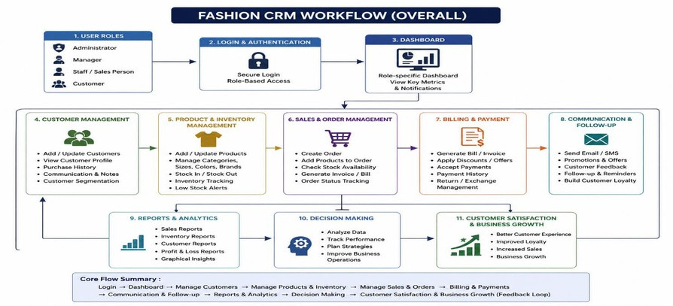
Objectives of the Project

The main objective of the Role-Based Fashion Business CRM project is to develop a centralized web-based application that automates and manages customer relationships, product inventory, sales activities, and business operations efficiently within the fashion clothing industry. The system aims to improve customer management by maintaining organized customer records, purchase history, and communication details while providing secure role-based access for administrators and staff members. It also focuses on simplifying inventory management, order processing, billing, and report generation through digital automation, thereby reducing manual errors and paperwork. Another objective of the project is to enhance operational efficiency, improve customer satisfaction, support data-driven decision making, and provide a scalable platform using MERN Stack technologies that can support future enhancements such as mobile integration, cloud deployment, and AI-based business features.

Figure 1.2: Overall Fashion CRM Workflow

Figure 1.2: Overall Fashion CRM Workflow

6

Screenshot 1.2 Home Page

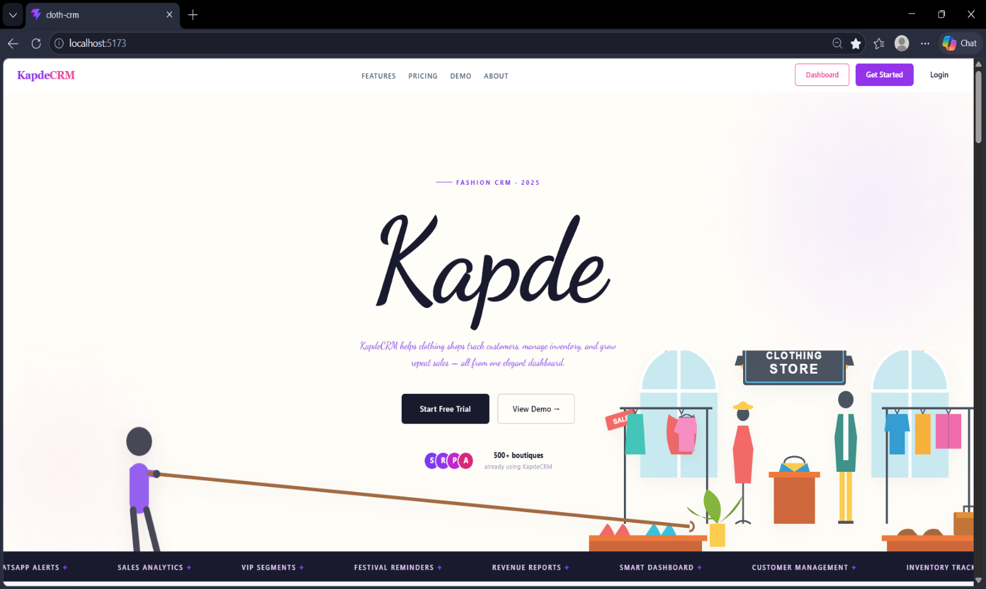

7

Scope of the Project

The scope of the Role-Based Fashion Business Customer Relationship Management (CRM) system focuses on providing a centralized and automated platform for managing customer relationships, clothing inventory, sales operations, and business activities within the fashion retail industry. The system is designed to support fashion clothing stores, boutiques, and retail businesses by simplifying daily operations through digital automation and organized data management.

The project includes customer management functionalities where businesses can store and maintain customer details, purchase history, preferences, and communication records in a centralized database. It also covers product and inventory management, allowing administrators and staff to manage clothing products, categories, pricing, sizes, colors, and stock availability efficiently. The system supports order processing, billing, and sales tracking, helping businesses monitor transactions and generate accurate reports.

The CRM application provides secure role-based access control, enabling administrators, managers, and staff members to access functionalities according to their responsibilities. The project also includes dashboard monitoring and report generation features that help management analyze sales performance, customer behavior, and inventory status for better decision making.

The system is developed as a web-based application using MERN Stack technologies, ensuring scalability, flexibility, and accessibility through modern web browsers. However, the current scope is limited to internal business management operations and does not include advanced e-commerce functionalities such as online shopping, live payment gateways, or customer mobile applications. Future enhancements may include cloud deployment, mobile integration, AI-bas recommendations, and advanced analytics features to further improve business operations and customer engagement.

8

Chapter 2: Literature Review & System Analysis

Customer Relationship Management (CRM) has become one of the most important technologies used by organizations to improve customer satisfaction, business operations, and long-term profitability. CRM systems help businesses manage customer interactions, sales activities, marketing strategies, and service operations through a centralized digital platform. Researchers and industry experts have highlighted the importance of CRM in improving customer engagement, operational efficiency, and business decision-making across multiple sectors, including retail and fashion industries.

According to the study “Customer Relationship Management: A Literature Review Approach,” CRM is considered a strategic business approach that combines technology, customer knowledge, and organizational processes to build strong customer relationships and improve business performance. The study explains that CRM systems support customer retention, service quality, and business growth through organized data management and communication.

Research on CRM in retail environments emphasizes the importance of data-driven customer management in modern businesses. Studies have shown that retailers can use customer data, purchase history, and behavioral analysis to understand customer preferences and improve marketing strategies. CRM systems provide businesses with tools for customer segmentation, personalized services, sales analysis, and inventory management, which are highly beneficial in fashion retail businesses.

Several researchers have also explored the integration of advanced technologies such as machine learning, artificial intelligence, and data analytics in CRM systems. These technologies help organizations automate customer analysis, improve recommendations, and predict customer behavior more accurately. AI-based CRM systems are becoming increasingly important in modern digital businesses because they enhance customer experience and support intelligent business decision-making.

In the fashion industry, customer satisfaction and personalized shopping experiences are essential factors for business success. Recent studies on fashion recommendation systems and AI applications in fashion retail indicate that digital technologies help businesses improve customer engagement, product recommendations, and sales performance. Modern fashion businesses are increasingly adopting CRM systems to manage customer preferences, product inventories, and communication channels more effectively.

Previous research also identified several limitations of traditional business management methods such as manual record keeping, disconnected systems, and spreadsheet-based management.

9

These methods create issues related to data redundancy, communication delays, inventory
mismanagement, and poor customer tracking. CRM systems address these problems by providing centralized databases, automation features, secure access control, and analytical reporting tools.

The literature review indicates that CRM systems play a critical role in improving operational efficiency, customer relationship management, and business performance. However, there is still a growing need for customized CRM solutions specifically designed for fashion clothing businesses that integrate customer management, inventory control, order processing, and role-based access management into a single platform. Therefore, the proposed Role-Based Fashion Business CRM system aims to provide a modern, secure, and scalable solution that fulfills the operational requirements of fashion retail businesses.

System Analysis

System analysis is the process of studying and evaluating an existing business system to identify its problems, limitations, and requirements for developing an improved solution. In the Role-Based Fashion Business CRM project, system analysis is performed to understand the operational challenges faced by fashion retail businesses and to design an efficient automated CRM system that improves customer management, inventory tracking, sales processing, and overall business operations.
The existing manual and paper-based systems used in many fashion businesses have several limitations. Customer records, inventory details, and sales information are often stored in physical files or spreadsheets, making data management difficult and time-consuming. These systems increase the chances of human errors, duplicate entries, missing records, and delayed report generation. Additionally, the absence of centralized data management and real-time information affects customer service quality and business decision-making.
The proposed Role-Based Fashion Business CRM system provides a centralized web-based solution that automates major business processes and improves operational efficiency. The system allows administrators, managers, and staff members to access functionalities according to their roles through secure authentication mechanisms. Customer information, product inventory, orders, and sales records are stored digitally in a MongoDB database, ensuring secure storage and efficient data retrieval.
The system analysis identifies several functional requirements, including user authentication, customer management, product management, inventory tracking, order processing, billing, dashboard monitoring, and report generation. The system also requires non-functional features such as security, scalability, responsiveness, reliability, and high performance. The application is developed using MERN Stack technologies including MongoDB, Express.js, React.js, and Node.js, which provide flexibility, scalability, and efficient communication between frontend and backend components.
The proposed CRM system improves workflow automation by reducing manual work, minimizing operational errors, and providing real-time business insights. It also supports better customer engagement, faster order processing, accurate inventory management, and analytical reporting for informed decision-making. Therefore, the system analysis demonstrates that the proposed Fashion Business CRM system is an effective digital solution for modern fashion retail businesses.

10

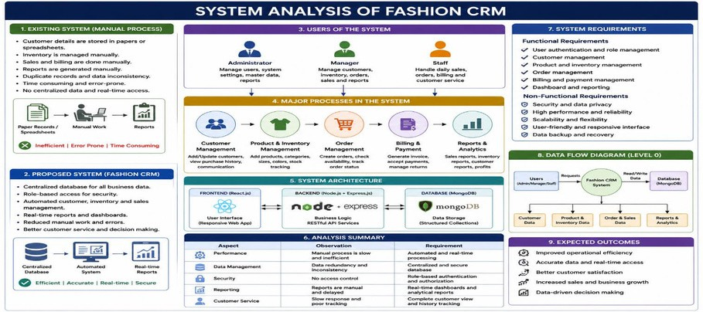
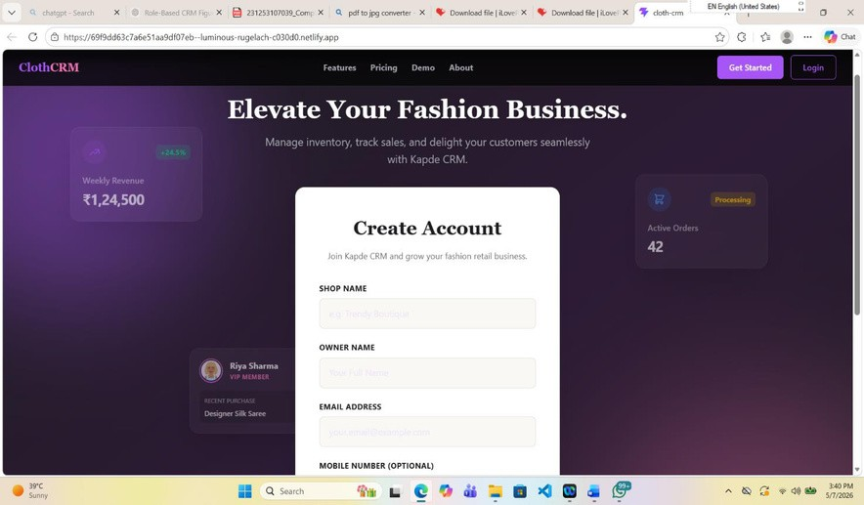
Figure 2.1: System analysis of fashion CRM

Figure 2.1: Seat Allocation

Screenshot 1.3 User Registration Page

11

Introduction to Topic

In today’s modern business environment, technology plays a major role in improving organizational efficiency, customer satisfaction, and operational management. Businesses across different industries are rapidly adopting digital solutions to automate manual processes and manage business activities more effectively. Among these industries, the fashion clothing industry is one of the fastest growing and highly competitive sectors where customer preferences, market trends, and product demands change continuously. To survive and grow in such a competitive market, fashion businesses must maintain strong customer relationships, manage inventory efficiently, monitor sales activities accurately, and provide personalized customer services. Traditional manual methods are no longer sufficient to fulfill these growing business requirements, which has increased the importance of Customer Relationship Management (CRM) systems in the fashion industry.

Customer Relationship Management (CRM) is a technology-based business strategy used to manage customer interactions, sales activities, communication records, and business operations through a centralized digital platform. CRM systems help organizations store customer information, analyze customer behavior, improve communication, automate workflows, and enhance customer satisfaction. In the fashion clothing industry, CRM systems are especially important because fashion businesses deal with large numbers of customers, multiple product categories, seasonal collections, and rapidly changing trends. Effective customer management and inventory control directly influence customer loyalty, sales growth, and overall business success.

Traditionally, many fashion retailers and boutiques use paper-based systems, spreadsheets, or disconnected software applications to manage customer records, inventory details, sales transactions, and billing operations. These traditional methods are time-consuming, difficult to maintain, and highly prone to human errors such as duplicate entries, missing records, inaccurate calculations, and delayed reporting. Manual systems also lack centralized data management and real-time information processing, making it difficult for businesses to track customer purchase history, monitor inventory availability, and generate analytical business reports. As business operations expand, these limitations negatively affect productivity, customer satisfaction, and business decision-making.

To overcome these problems, the “Role-Based Fashion Business CRM” system is developed as a centralized web-based application designed specifically for fashion retail businesses. The system aims to automate customer management, inventory tracking, sales processing, order management, billing, and reporting through a secure and user-friendly platform. The CRM application provides role-based access control, allowing administrators, managers, and staff members to access functionalities according to their responsibilities. This improves data security, workflow management, and operational coordination within the organization.

The proposed Fashion CRM system is developed using modern MERN Stack technologies, including MongoDB for database management, Express.js and Node.js for backend server development, and React.js for creating an interactive and responsive frontend interface.

12

The application follows a client-server architecture where frontend components communicate with backend services using RESTful APIs. This architecture ensures smooth data processing, efficient communication, scalability, flexibility, and high system performance.

The system includes multiple modules such as customer management, product management, inventory management, sales tracking, order processing, dashboard analytics, and report generation. The customer management module helps businesses maintain customer details, purchase history, communication records, and preferences in a centralized database. Product and inventory management modules allow businesses to manage clothing categories, stock availability, product pricing, sizes, and colors efficiently. The sales and order management modules automate billing, order tracking, invoice generation, and payment management. The dashboard and reporting modules provide real-time business insights and analytical reports that support better decision-making and business planning.

One of the major advantages of the proposed CRM system is workflow automation. Routine business tasks such as customer registration, inventory updates, billing, and report generation are automated digitally, reducing manual workload and operational errors. The system also improves customer engagement by helping businesses understand customer behavior and provide personalized services based on customer preferences and purchasing patterns.

The Role-Based Fashion Business CRM system also supports digital transformation within the fashion industry by replacing traditional manual processes with modern automated technologies. The system improves operational efficiency, data accuracy, communication management, and overall business productivity. Additionally, the scalable architecture allows future enhancements such as cloud deployment, mobile application integration, online payment gateway support, artificial intelligence-based product recommendations, and advanced business analytics.

In conclusion, the Role-Based Fashion Business CRM project demonstrates the practical implementation of modern web technologies for solving real-world business management problems in the fashion industry. The system provides a secure, scalable, efficient, and user-friendly solution for managing customer relationships and business operations effectively. By integrating customer management, inventory control, sales monitoring, and reporting into a single digital platform, the project helps fashion businesses improve customer satisfaction, streamline workflows, and achieve long-term business growth.

13

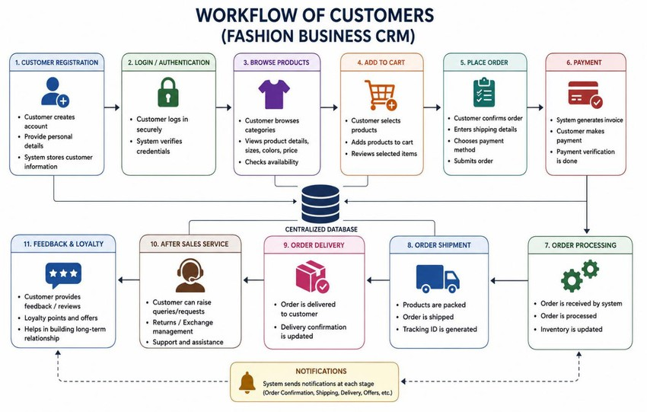
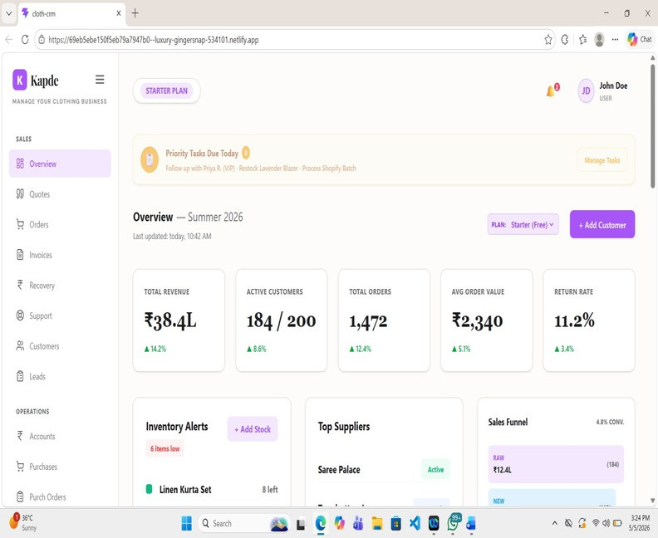
Figure 2.2: Workflow Of Customers

Figure 2.2: Workflow Of Customers

Screenshot 1.4 Admin Dashboard

14

Study of Existing Fashion CRM Methods

Customer Relationship Management (CRM) systems have become essential tools for modern fashion businesses to improve customer satisfaction, manage customer data, and increase sales performance. Existing Fashion CRM methods mainly focus on customer data management, personalized marketing, customer retention, inventory control, and sales analysis. Traditional fashion businesses initially relied on manual customer management methods such as paper records, spreadsheets, and disconnected software applications. However, with the growth of digital technologies and online shopping platforms, modern CRM systems have evolved into advanced web-based and cloud-based solutions that provide automated and centralized business management.

One of the most used existing CRM methods in the fashion industry is Customer Database Management. In this method, businesses store customer information such as personal details, purchase history, preferences, and communication records in centralized databases. Fashion companies use this information to analyze customer behavior and improve personalized services. Research studies show that customer databases are among the most widely adopted CRM technologies in fashion businesses because they help organizations improve customer retention and marketing strategies.

Another important existing CRM method is RFM (Recency, Frequency, Monetary) Analysis, which is widely used in fashion retail businesses for customer segmentation. This method categorizes customers based on their recent purchases, purchase frequency, and spending behavior. Businesses use RFM analysis to identify loyal customers, potential customers, and inactive customers for targeted marketing campaigns and promotional offers. Several modern fashion CRM systems integrate RFM dashboards and analytical tools to improve customer retention and sales growth.

E-CRM (Electronic Customer Relationship Management) is another advanced CRM method used in online fashion retail businesses. E-CRM systems use digital platforms such as websites, mobile applications, email marketing, and social media to manage customer interactions and provide personalized shopping experiences. These systems help businesses monitor online customer activities, provide product recommendations, and improve communication efficiency. Research indicates that e-CRM significantly improves customer satisfaction, relationship quality, and purchase intentions in fashion e-commerce environments.

Fashion businesses also use Loyalty Management Systems as part of CRM strategies to improve customer retention. Loyalty programs provide reward points, discounts, membership benefits, and promotional offers to regular customers. Studies show that direct reward programs and personalized promotional strategies positively influence customer loyalty and customer engagement in fashion businesses.

Modern CRM methods increasingly use Artificial Intelligence (AI), Machine Learning, and Data Mining techniques for customer behavior analysis and product recommendations. AI-based fashion CRM systems analyze customer preferences, shopping patterns, and outfit compatibility to provide
15

personalized recommendations and improve customer shopping experience. Research in computational fashion recommendation systems demonstrates that machine learning models and recommendation algorithms significantly improve fashion product suggestions and customer engagement.
Another emerging CRM approach in fashion businesses is WhatsApp Business-based CRM systems. Small and medium fashion businesses use messaging platforms to communicate with customers, manage orders, and provide support services. However, manual handling of customer interactions through messaging applications often creates delays and unorganized customer records. Therefore, integrated CRM systems are being developed to automate customer communication and improve sales management in online fashion businesses.

Despite these advancements, many existing CRM methods still face limitations such as lack of centralized integration, poor scalability, insufficient security, delayed reporting, and difficulties in handling large customer datasets. Traditional systems often fail to provide complete automation of customer management, inventory tracking, sales monitoring, and role-based access control within a single platform. Therefore, there is a growing need for a modern Role-Based Fashion CRM system that integrates customer management, inventory control, sales processing, reporting, and business analytics into a secure and scalable web-based solution.

15

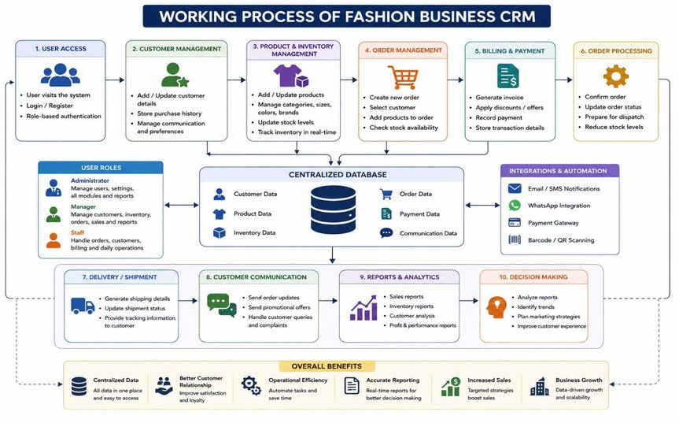
Figure 2.3: Working Process Of CRM

Figure 2.3: Working Process Of CRM

16

Chapter 3: Project Management
Project management is an important process that involves planning, organizing, developing, monitoring, and controlling all activities required for the successful completion of a software project. In the development of the Role-Based Fashion Business Customer Relationship Management (CRM) system, project management helps ensure that the project is completed within the planned time, budget, and quality standards while meeting all business and technical requirements.

The Fashion Business CRM project follows a systematic software development process that includes requirement analysis, system design, development, testing, implementation, and maintenance. The project begins with identifying the problems faced by fashion businesses in managing customers, inventory, sales, and orders using traditional manual methods. After gathering requirements from users and studying existing systems, the project objectives and system functionalities are clearly defined.

During the planning phase, project schedules, development activities, technologies, and resources are determined. The MERN Stack technologies including MongoDB, Express.js, React.js, and Node.js are selected for system development because they provide scalability, flexibility, and efficient web application performance. The project is divided into multiple modules such as user authentication, customer management, inventory management, order processing, billing, dashboard monitoring, and report generation.

The system design phase focuses on creating database structures, user interfaces, workflow diagrams, and system architecture. Frontend and backend components are developed separately and integrated using RESTful APIs for smooth communication and real-time data processing. Role-based authentication and authorization mechanisms are implemented to ensure secure access control for administrators, managers, and staff members.

Testing and debugging are important stages of project management where the developed system is checked for functionality, performance, security, and usability. Different testing methods such as unit testing, integration testing, and system testing are performed to identify and resolve errors before deployment. After successful testing, the CRM system is implemented and made ready for business use.

Effective project management ensures proper coordination between development activities, improves workflow efficiency, minimizes risks, and supports successful system deployment. The Role-Based Fashion Business CRM project demonstrates how organized project management practices help in developing a reliable, secure, and user-friendly business management solution for the fashion industry.

17

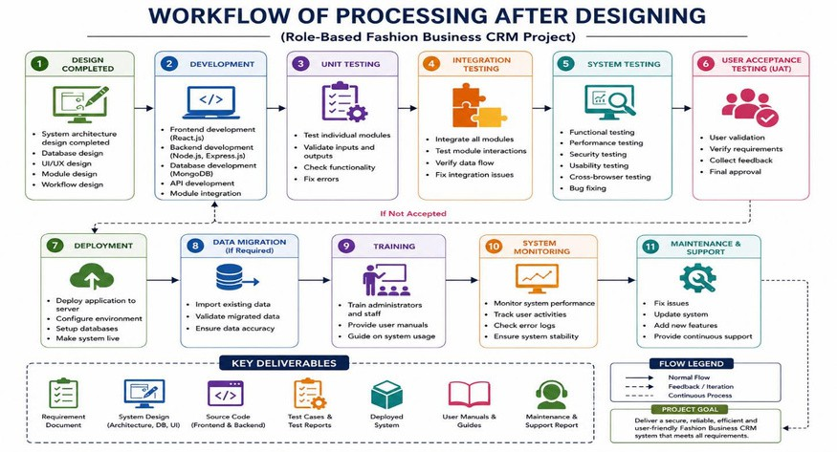
Figure 3.1: Workflow Of Processing After Designing

Figure 3.1: Workflow Of Processing After Designing

18

Introduction to Methodology

Methodology refers to the systematic approach, techniques, and procedures used for planning, developing, testing, and implementing software projects. In the development of the Role-Based Fashion Business Customer Relationship Management (CRM) system, the methodology provides a structured framework to ensure that all project requirements are analyzed properly, and the system is developed efficiently, securely, and successfully. A well-defined methodology helps in managing project activities, reducing development risks, improving software quality, and achieving project objectives within the planned time and resources.

The development of the Fashion Business CRM system follows the Software Development Life Cycle (SDLC) methodology, which includes several important phases such as requirement analysis, system design, development, testing, deployment, and maintenance. Each phase plays a significant role in building a reliable and user-friendly CRM application that fulfills the operational needs of fashion retail businesses.

The first phase of the methodology is requirement analysis, where business problems, user needs, and system functionalities are identified through research and study of existing business processes. During this stage, the requirements related to customer management, inventory tracking, sales processing, role-based authentication, reporting, and dashboard monitoring are collected and analyzed.

The next phase is system design, where the architecture of the CRM system, database structure, workflow diagrams, and user interface designs are prepared. The system is designed using client-server architecture, where frontend and backend components communicate through RESTful APIs for secure and efficient data processing.

In the development phase, the system is implemented using MERN Stack technologies including MongoDB, Express.js, React.js, and Node.js. React.js is used to create responsive frontend interfaces, while Node.js and Express.js handle backend logic and API services. MongoDB is used as the database for storing customer records, product information, sales data, and inventory details securely
.
After development, testing is performed to verify system functionality, performance, security, and usability. Different testing methods such as unit testing, integration testing, and system testing are conducted to identify and remove software errors. Once testing is completed successfully, the system is deployed for practical use within the business environment.

Finally, the maintenance phase ensures continuous monitoring, updates, bug fixing, and future improvements to maintain system performance and support business growth. Therefore, the selected methodology helps in developing a scalable, secure, efficient, and user-friendly Fashion Business CRM system that improves customer relationship management and overall business operations.

19

Methodology is a structured and organized approach used for planning, designing, developing, testing, implementing, and maintaining a software system. In software engineering, methodology plays a vital role in ensuring that the project is developed systematically, efficiently, and according to user requirements. A proper methodology helps developers manage project activities, monitor progress, improve software quality, minimize development risks, and complete the project within the planned schedule and budget. For the development of the Role-Based Fashion Business Customer Relationship Management (CRM) system, a systematic methodology is followed to create a reliable, scalable, and user-friendly application that fulfills the operational requirements of fashion retail businesses.

The fashion industry is highly customer-oriented and rapidly changing, requiring businesses to manage customer relationships, product inventory, sales activities, and order processing efficiently. Traditional manual systems used in many fashion businesses create challenges such as data redundancy, operational delays, inaccurate record management, and poor customer service. Therefore, the proposed Fashion Business CRM system is developed using a modern software development methodology that supports automation, centralized data management, real-time processing, and secure business operations.

The project methodology follows the Software Development Life Cycle (SDLC), which is one of the most widely used approaches in software engineering. SDLC provides a step-by-step process for developing high-quality software systems through different phases including requirement gathering, system analysis, system design, development, testing, deployment, and maintenance. Each phase has
a specific objective and contributes to the successful completion of the project.

The first phase of the methodology is requirement gathering and analysis. In this stage, the problems faced by fashion businesses using manual systems are identified, and the functional and non-functional requirements of the CRM system are collected. Functional requirements include customer management, inventory tracking, order processing, billing, reporting, and role-based access control, while non-functional requirements include security, scalability, performance, reliability, and responsiveness. Understanding these requirements helps developers design a system that fulfills business needs effectively.

The second phase is system analysis, where the existing system is studied to identify its limitations and weaknesses. The analysis phase helps determine how the proposed Fashion CRM system can improve customer relationship management, automate business workflows, and enhance operational efficiency. During this stage, feasibility studies such as technical feasibility, operational feasibility, and economic feasibility are also performed to evaluate whether the proposed system can be implemented successfully.

The system design phase focuses on creating the architecture and structure of the application. In this phase, database schemas, data flow diagrams, use case diagrams, workflow diagrams, and user

20

interface designs are prepared. The Fashion CRM system follows a client-server architecture where the frontend and backend communicate through RESTful APIs. The frontend is designed to provide
a responsive and user-friendly experience, while the backend manages business logic, authentication, and database operations securely.

The development phase involves the actual implementation of the system using MERN Stack technologies. MongoDB is used as the database management system to store customer details, inventory records, orders, and sales information. Express.js and Node.js are used for backend development and API integration, while React.js is used to develop an interactive frontend user interface. Role-based authentication and authorization mechanisms are implemented to ensure secure access for administrators, managers, and staff users according to their responsibilities.

21

Selection of Development Methodology

The selection of an appropriate development methodology is one of the most important steps in software project development because it defines the process, structure, and techniques used to build the system successfully. For the development of the Role-Based Fashion Business Customer Relationship Management (CRM) system, the Software Development Life Cycle (SDLC) methodology is selected as the primary development approach. The SDLC methodology provides a systematic and organized framework for planning, analyzing, designing, developing, testing, implementing, and maintaining the software application efficiently.

The Fashion Business CRM system includes multiple modules such as customer management, inventory management, order processing, billing, dashboard analytics, and role-based authentication. Since the project requires proper planning, structured workflow, and secure implementation, the SDLC methodology is considered suitable for managing the entire software development process. The methodology helps developers understand business requirements clearly and ensures that each phase of development is completed systematically before moving to the next phase.

One of the major reasons for selecting the SDLC methodology is its ability to improve software quality and project management. The methodology divides the project into different phases including requirement gathering, system analysis, system design, coding, testing, deployment, and maintenance. This phased approach allows developers to identify errors and issues at early stages, reducing development risks and improving system reliability. It also supports better documentation, progress tracking, and communication between developers and users.

The requirement analysis phase helps in understanding the operational problems faced by fashion businesses and identifying the functionalities needed in the CRM system. During the design phase, system architecture, database structures, user interfaces, and workflow diagrams are prepared carefully. The development phase focuses on implementing applications using MERN Stack technologies such as MongoDB, Express.js, React.js, and Node.js. Testing phases ensure that all modules work correctly and securely before deployment.

Another important reason for selecting the SDLC methodology is its flexibility and scalability. The Fashion Business CRM system may require future enhancements such as cloud integration, mobile applications, AI-based recommendations, and advanced analytics. The structured nature of SDLC supports easy system maintenance and future upgrades without affecting existing functionalities.

The selected methodology also improves teamwork and project coordination because all project activities are clearly defined and documented. Developers, testers, and project stakeholders can work efficiently by following a predefined development process. Additionally, role-based management and modular development become easier to implement using a systematic methodology.

In conclusion, the Software Development Life Cycle (SDLC) methodology is selected for the development of the Role-Based Fashion Business CRM system because it provides a structured,

22

reliable, and efficient approach for software development. The methodology helps ensure proper requirement analysis, systematic implementation, quality assurance, secure development, and successful deployment of the CRM system while supporting future scalability and technological enhancements.

The selection of a suitable development methodology is a critical process in software engineering because it determines how the project will be planned, designed, developed, tested, implemented, and maintained. A proper development methodology helps developers organize project activities, manage resources efficiently, reduce risks, improve software quality, and ensure successful completion of the project within the specified time and budget. For the development of the Role-Based Fashion Business Customer Relationship Management (CRM) system, the Software Development Life Cycle (SDLC) methodology is selected as the primary approach because it provides a structured and systematic framework for software development.

The Fashion Business CRM system is a web-based application that includes multiple modules such as customer management, inventory management, product management, billing, order processing, sales tracking, dashboard analytics, and report generation. Since the system involves various interconnected functionalities and role-based security mechanisms, it requires a well-organized development process that ensures proper coordination between all stages of development. The SDLC methodology is suitable for this project because it divides the development process into clear and manageable phases, making the project easier to plan, monitor, and control.

One of the main reasons for selecting the SDLC methodology is its systematic approach toward requirement analysis and project planning. In the Fashion CRM project, it is important to understand the operational challenges faced by fashion businesses, including customer data management issues, inventory tracking difficulties, manual billing errors, and inefficient sales monitoring. The requirement gathering phase of SDLC allows developers to identify these business problems clearly and define the functional and non-functional requirements of the system accurately. This helps in designing a solution that fulfills business needs effectively.

Another important factor behind selecting SDLC is its strong focus on system analysis and design. Before development begins, the methodology ensures that system architecture, database structures, user interfaces, workflow diagrams, and data flow models are designed properly. For the Fashion CRM system, careful planning of modules such as role-based authentication, centralized database management, inventory tracking, and order management is essential to ensure smooth business operations and secure data handling. The design phase reduces development confusion and helps developers create scalable and efficient system architecture.

The SDLC methodology also supports modular development, which is highly beneficial for the Fashion Business CRM project. Each module of the CRM system, such as customer management, product management, billing, and reporting, can be developed and tested separately before integrating them into the final application. This modular approach improves development efficiency, simplifies debugging, and makes system maintenance easier.

23

Project Planning

Project planning is an essential phase in software development that involves organizing, scheduling, and managing all activities required for the successful completion of a project. It provides a clear roadmap for developers by defining project objectives, resources, timelines, technologies, tasks, and responsibilities. Proper project planning helps ensure that the software system is developed efficiently within the specified time, budget, and quality standards. In the development of the Role-Based Fashion Business Customer Relationship Management (CRM) system, project planning plays a major role in managing development activities systematically and achieving the project goals successfully.

The primary objective of the Fashion Business CRM project is to develop a centralized web-based application that automates customer management, inventory tracking, sales processing, order management, billing, and reporting for fashion retail businesses. During the planning phase, all project requirements and business problems are analyzed carefully to determine the functionalities needed in the system. The planning process helps developers understand the workflow of fashion businesses and identify the technologies and resources required for implementation.

The project planning process begins with requirement gathering and analysis. In this stage, information about customer management, product inventory, sales activities, billing processes, and role-based access requirements is collected and studied. The limitations of traditional manual systems are identified, and solutions are planned to improve operational efficiency through digital automation. Functional requirements such as customer registration, product management, dashboard monitoring, report generation, and secure authentication are finalized during this phase.

After requirement analysis, project scheduling and task management are performed. The complete development process is divided into different phases including system analysis, system design, frontend development, backend development, database integration, testing, deployment, and maintenance. Each task is assigned a timeline to ensure that development activities are completed systematically and on schedule. Proper scheduling helps avoid delays and improves project coordination among team members.

Technology selection is another important part of project planning. The Fashion Business CRM system is developed using MERN Stack technologies including MongoDB, Express.js, React.js, and Node.js. MongoDB is selected for database management because it provides flexibility and efficient storage of customer and inventory data. React.js is used to create a responsive and interactive frontend interface, while Express.js and Node.js are used for backend development and API integration. The selected technologies support scalability, high performance, and efficient web application development.

Resource planning is also included in the project planning process. Hardware and software requirements such as computers, internet connectivity, development tools, code editors, database

24

systems, and testing environments are identified before development begins. Human resources including developers, testers, and project supervisors are also considered to ensure smooth project execution.

Risk management is another important activity during project planning. Potential risks such as technical difficulties, security issues, database errors, project delays, and system integration problems are identified in advance. Appropriate strategies are planned to minimize these risks and maintain smooth development progress. Regular testing and monitoring are also planned to ensure software quality and system reliability.

The project planning phase also includes designing development strategies and workflow management. The CRM system is divided into modules such as user authentication, customer management, inventory management, sales tracking, order processing, and reporting. Modular planning helps developers focus on individual functionalities separately, improving development efficiency and reducing complexity.

Testing and quality assurance activities are planned during the project planning phase to ensure that the final system works accurately and securely. Various testing techniques such as unit testing, integration testing, system testing, and performance testing are scheduled to identify and resolve errors before deployment. Security measures such as role-based authentication and secure database communication are also planned carefully to protect business data.

Finally, deployment and maintenance planning are performed to ensure long-term system usability and future scalability. The project planning process considers future enhancements such as mobile application integration, cloud deployment, AI-based recommendations, and advanced analytics features. Continuous maintenance and updates are planned to improve system performance and support changing business requirements.

In conclusion, project planning provides a structured approach for the successful development of the Role-Based Fashion Business CRM system. It helps organize project activities, allocate resources efficiently, manage risks, improve communication, and ensure timely project completion. Effective project planning supports the development of a secure, scalable, and user-friendly CRM application that improves customer relationship management and business operations within the fashion industry.

25

Chapter 4: System Design

Introduction
System design is an important phase in software development that focuses on creating the overall structure, architecture, components, and workflow of a software system. It acts as a blueprint for the development process by defining how the system will function, how data will flow between modules, and how different components will interact with each other. A well-designed system improves software efficiency, scalability, security, maintainability, and user experience. In the development of the Role-Based Fashion Business Customer Relationship Management (CRM) system, system design plays a major role in organizing business functionalities and ensuring smooth operation of the application.

The primary objective of the Fashion Business CRM system design is to develop a centralized and automated platform for managing customer relationships, product inventory, sales operations, billing, order processing, and reporting within fashion retail businesses. The system is designed to reduce manual work, improve operational efficiency, and provide secure access to business information through role-based authentication and authorization mechanisms.

The proposed CRM system follows a client-server architecture where frontend and backend components communicate through RESTful APIs. The frontend is developed using React.js to provide a responsive, interactive, and user-friendly interface, while the backend is developed using Node.js and Express.js to handle server-side operations, business logic, and API services. MongoDB is used as the database management system for storing customer records, inventory data, sales transactions, and business reports securely and efficiently.

The system design includes multiple modules such as user authentication, customer management, product management, inventory tracking, order processing, billing, dashboard analytics, and report generation. Each module is designed separately to simplify development, improve maintainability, and support future scalability. Role-based access control is implemented to ensure that administrators, managers, and staff members can access functionalities according to their responsibilities and permissions.

Database design is another important part of the system design process. Collections and relationships are planned carefully to store customer details, product information, sales records, and order data efficiently. Proper database design improves data accuracy, reduces redundancy, and supports fast data retrieval for real-time business operations.

The system design phase also includes the preparation of diagrams such as use case diagrams, data flow diagrams (DFD), entity relationship diagrams (ERD), workflow diagrams, and system architecture diagrams. These diagrams help developers and stakeholders understand the overall working process of the CRM application clearly.

26

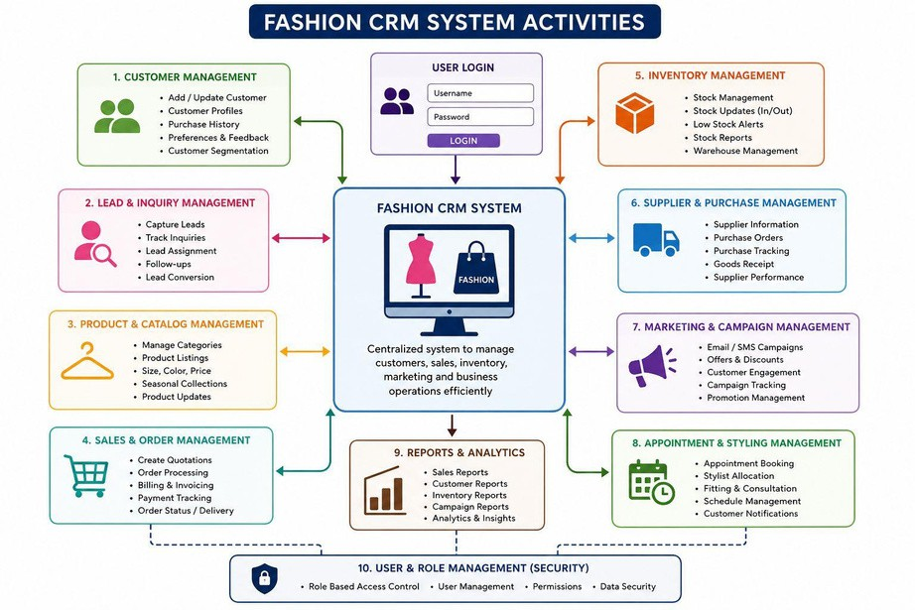
Security and performance considerations are also included in the system design. Authentication mechanisms, secure API communication, password encryption, and database protection techniques are implemented to ensure data privacy and system reliability. The system is designed to handle multiple users efficiently while maintaining high performance and responsiveness.

Overall, the system design phase provides a strong foundation for the successful development of the Role-Based Fashion Business CRM system. It helps organize system functionalities, improve workflow management, and ensure that the final application is secure, scalable, efficient, and capable of supporting future enhancements such as cloud deployment, mobile applications, and AI-based business features.

Figure 4.1: System Activities

27

System Architecture
The system architecture of the Role-Based Fashion Business Customer Relationship Management (CRM) system represents the overall structure and interaction between different components of the application. The system follows a client-server architecture where the frontend, backend, database, and users communicate with each other to perform business operations efficiently. The architecture is designed to provide scalability, security, flexibility, and smooth workflow management for fashion retail businesses.

In the Fashion CRM system, users such as Admin, Manager, and Staff interact with the application through a web browser. The frontend of the system is developed using React.js, which provides a responsive and user-friendly interface for managing customers, inventory, ordering, billing, and reports. Users send requests through the frontend interface to access different functionalities of the CRM system.

The frontend communicates with the backend server through RESTful APIs. The backend is developed using Node.js and Express.js, which handle business logic, user authentication, request processing, and data management operations. The backend server processes user requests, validates data, performs operations, and sends responses back to the frontend interface.

MongoDB is used as the database management system for storing customer records, product information, inventory details, sales transactions, orders, and reports. The database provides centralized and secure storage of business data while supporting fast data retrieval and real-time updates. The backend server interacts directly with MongoDB to store, update, delete, and retrieve information efficiently.

The system also includes role-based authentication and authorization mechanisms to ensure secure access control. Administrators have full access to all system functionalities, while managers and staff members can access specific modules according to their assigned roles and permissions. This improves data security and workflow management within the organization.

28

Database Design
Database design is an important process in software development that focuses on organizing, storing, and managing data efficiently within a system. A well-designed database improves data accuracy, security, consistency, and retrieval performance while reducing redundancy and maintaining proper relationships between data entities. In the Role-Based Fashion Business Customer Relationship Management (CRM) system, database design plays a major role in managing customer records, product information, inventory details, sales transactions, orders, billing, and user authentication securely and efficiently.

The Fashion Business CRM system uses MongoDB as the database management system. MongoDB is a NoSQL database that stores data in flexible JSON-like document structures called collections. It is selected because it provides scalability, high performance, flexibility, and efficient handling of dynamic business data. The database stores all business-related information in a centralized format, allowing administrators and staff members to access updated data in real time.

The database design includes multiple collections such as Users, Customers, Products, Inventory, Orders, Sales, Billing, and Reports. Each collection stores specific information related to business operations. The Users collection contains login credentials, role information, and authentication details for administrators, managers, and staff members. The Customers collection stores customer names, contact details, purchase history, preferences, and communication records. The Products collection manages clothing product information such as product name, category, size, color, pricing, and stock availability.

The Inventory collection tracks stock levels and product availability to ensure proper inventory management. The Orders collection stores customer order details including ordered products, quantities, payment status, and delivery information. Sales and Billing collections maintain transaction records, invoices, payment details, and sales reports for business analysis. The Reports collection stores analytical data used for generating dashboards and business performance summaries.

Relationships between collections are maintained using unique identifiers such as customer IDs, product IDs, and order IDs. This helps establish proper connections between customers, products, sales transactions, and inventory records. The database is designed to support fast data retrieval, secure storage, and efficient processing of business operations.

Security is another important consideration in database design. Passwords and sensitive user information are stored securely using encryption and authentication mechanisms. Proper access control ensures that only authorized users can modify or access business data according to their assigned roles and permissions.

The database design also supports future scalability and enhancements. Since fashion businesses continuously grow and manage large amounts of customer and product data, the database structure is designed to handle increasing records efficiently without affecting system performance. Future features such as cloud integration, AI-based analytics, mobile applications, and online payment systems can also be integrated easily with the existing database structure.

Overall, the database design of the Fashion Business CRM system provides a secure, centralized, scalable, and efficient data management solution that supports smooth customer relationship management, inventory control, sales monitoring, and business reporting operations.

29

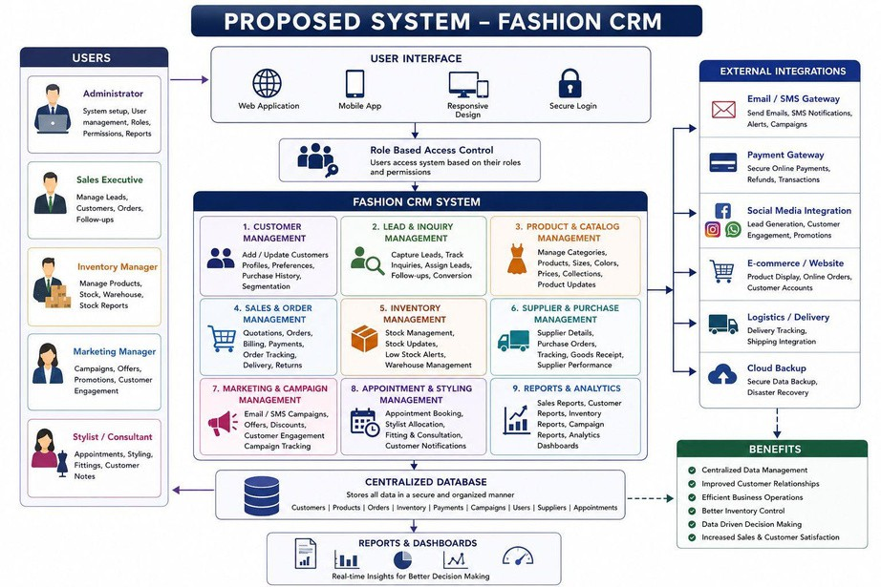
Figure 4.2: Proposed System

Figure 4.3: End To End Lifecycle

30

Chapter 5: Implementation and Testing

Introduction

Implementation and testing are important phases of software development that focus on developing the system and ensuring that it works correctly according to user requirements. In the Role-Based Fashion Business CRM project, implementation involves developing the application using MERN Stack technologies such as MongoDB, Express.js, React.js, and Node.js. Different modules like customer management, inventory management, order processing, billing, authentication, and reporting are integrated to create a completely web-based CRM system. Testing is performed after development to identify and fix errors, improve system security, and verify system functionality and performance. Various testing methods such as unit testing, integration testing, and system testing are used to ensure that the CRM application is reliable, secure, efficient, and ready for practical business use.

Tools and Technologies

The Fashion Clothing Customer Relationship Management (CRM) system is developed using the MERN Stack, which comprises MongoDB, Express.js, React.js, and Node.js as its primary technologies. MongoDB serves as the database system used to store and manage customer, product, and sales data in a flexible, document-oriented format suitable for scalable web applications. Express.js and Node.js are utilized on the backend to create a powerful server environment that handles application logic, user authentication, API routing, and secure data processing through RESTful APIs. On the frontend, React.js is used to develop an interactive and responsive user interface that allows users and administrators to efficiently manage business operations through dashboards and forms. Additional tools such as Visual Studio Code for development, JavaScript and CSS for coding and styling, and web browsers like Google Chrome for accessing and testing the application were also employed. The combination of these technologies provides a modern, scalable, and efficient framework for building a secure, high-performance web-based CRM system tailored for fashion retail businesses.

Module Description

A Fashion CRM Project is designed to manage customer relationships and streamline business operations in the fashion industry. The system includes modules such as Customer Management, Lead & Inquiry Management, and Product & Catalog Management to store customer details, track inquiries, and manage fashion collections, sizes, colors, and pricing. It also supports Sales & Order Management for handling orders, invoices, payments, and delivery tracking, helping businesses improve customer satisfaction and operational efficiency.

31

The project also contains Inventory Management, Marketing & Campaign Management, Supplier & Vendor Management, and Reporting modules to monitor stock, run promotional campaigns, manage vendors, and generate business insights through dashboards and analytics. Additionally, Appointment & Styling Management helps schedule consultations and fittings, while User & Role Management ensures secure access control for administrators, sales teams, designers, and other staff members.

Testing and Results

The Fashion CRM Project was tested using unit testing, integration testing, and system testing to ensure that all modules worked properly. Features such as customer management, order processing, inventory tracking, and report generation were checked for accuracy, security, and performance.

The results showed that the system works efficiently with fast processing and accurate data management. It reduced manual work, improved customer handling, and helped manage sales.

32

Chapter 6: Results and Discussion

The Fashion CRM Project achieved significant improvements in managing customer relationships, sales operations, inventory control, and marketing activities within the fashion business environment. Before implementing the system, many business processes were handled manually, which often caused data duplication, communication gaps, delayed order processing, and inventory management issues. After introducing the CRM system, all customer and business information was stored in a centralized database, allowing staff members to access accurate and updated records easily. The customer management module helped maintain detailed profiles including customer preferences, purchase history, sizes, measurements, and feedback, enabling businesses to provide more personalized services and improve customer satisfaction.

The lead and inquiry management module successfully tracked customer inquiries from different channels such as websites, social media platforms, exhibitions, and direct visits. This helped the sales team respond quickly to customer requests and convert more leads into actual sales. The product and catalog management module simplified the handling of fashion collections, categories, colors, sizes, pricing, and seasonal products. Businesses could easily update product information and display organized catalogs for customers. The sales and order management module automated quotation generation, billing, payment tracking, invoice management, and order status updates, reducing paperwork and minimizing human errors. Delivery tracking and return management features also improved the overall shopping experience for customers.

The inventory management module played a major role in improving stock control and warehouse operations. The system provided real-time stock updates, stock movement tracking, and automatic low-stock alerts, helping businesses maintain proper inventory levels and avoid both overstocking and stock shortages. This improved product availability and reduced financial losses caused by poor inventory management. The supplier and vendor management module also enhanced communication with suppliers by maintaining vendor details, purchase records, and fabric sourcing information in a structured manner. Businesses could easily generate purchase orders and monitor supplier performance, leading to better coordination and faster procurement processes.

The marketing and campaign management module helped businesses strengthen customer engagement through email campaigns, SMS notifications, promotional offers, and discount management. By analyzing customer purchase behavior and preferences, the system supported targeted marketing strategies that increased customer retention and repeat purchases. Personalized promotions and seasonal offers improved customer interaction and brand loyalty. The appointment and styling management module was especially useful for fashion boutiques and designer stores, as it allowed customers to schedule appointments for personal styling, fittings, and consultations. This improved service quality and enhanced the customer experience.

The reporting and analytics module provided detailed dashboards and reports related to sales performance, customer trends, inventory status, campaign effectiveness, and business growth.

33

Managers could use these reports to make informed business decisions and identify areas requiring improvement. Graphical reports and real-time analytics increased transparency and simplified performance evaluation. User and role management ensured secure access to the system by assigning permissions to administrators, sales executives, inventory managers, and designers according to their responsibilities. This improved data security and prevented unauthorized access.

During the testing phase, the system underwent unit testing, integration testing, system testing, and user acceptance testing to ensure smooth performance and reliability. The testing results confirmed that the system handled large amounts of data efficiently, generated reports accurately, and maintained secure access control. The response time of the system was fast, and all modules worked together without major errors. Users found the interface simple, user-friendly, and easy to navigate. Overall, the Fashion CRM Project successfully reduced manual workload, improved operational efficiency, enhanced customer relationship management, increased sales opportunities, and supported better decision-making processes. The project proved to be a valuable solution for modern fashion businesses aiming to improve productivity, customer satisfaction, and long-term business growth.

34

Chapter 7: Conclusion
The Fashion CRM Project was successfully developed to improve customer relationship management and automate various business operations in the fashion industry. The system integrated important modules such as customer management, sales and order processing, inventory tracking, marketing management, supplier handling, and reporting into a single platform. By replacing manual processes with an organized digital system, the project helped reduce errors, save time, and improve overall operational efficiency. The centralized database made it easier to store and access customer and business information, enabling better communication and personalized customer service.

The project also enhanced inventory control, sales tracking, and marketing activities, helping businesses make faster and more accurate decisions. Features such as real-time stock updates, campaign management, and detailed analytical reports contributed to better productivity and customer satisfaction. Testing results confirmed that the system is reliable, secure, and user-friendly. Overall, the Fashion CRM Project proved to be an effective solution for managing fashion business.

35

Chapter 8: Future Scope

The future scope of the Fashion CRM Project is broad, as the system can be further enhanced with advanced technologies and additional features to meet the growing demands of the fashion industry. One major improvement can be the integration of Artificial Intelligence (AI) and Machine Learning (ML) to analyze customer behavior, predict fashion trends, and provide personalized product recommendations. AI-based recommendation systems can help businesses suggest outfits, accessories, and collections according to customer preferences, purchase history, and browsing patterns. Predictive analytics can also help businesses forecast sales, manage inventory more effectively, and identify future market trends.

The project can also be expanded by integrating advanced e-commerce features such as online shopping platforms, mobile applications, and digital payment gateways. Customers could directly browse fashion catalogs, place orders, track deliveries, and receive personalized offers through mobile devices. A mobile CRM application would allow sales teams and managers to access business data anytime and anywhere, improving flexibility and faster decision-making. Integration with social media platforms such as Instagram, Facebook, and WhatsApp can further improve customer engagement and support direct communication, social media marketing, and online promotions.

Another important future enhancement is the implementation of cloud computing technology. A cloud-based Fashion CRM system would provide better data security, remote accessibility, automatic backups, and scalability for growing businesses. Multiple branches or stores could access centralized data in real time, improving coordination and operational efficiency. Cloud integration would also reduce hardware maintenance costs and support smooth software updates. Additionally, integrating the system with Enterprise Resource Planning (ERP) software can help manage accounting, payroll, supply chain operations, and finance within a single business platform.

The inventory and supply chain modules can also be improved using technologies such as RFID (Radio Frequency Identification) and barcode scanning systems for real-time product tracking. These technologies would help businesses monitor stock movement more accurately, reduce inventory losses, and improve warehouse management. Automated stock replenishment systems could also be introduced to reduce manual effort and avoid stock shortages. Supplier management can be enhanced through automated communication systems and vendor performance analysis tools.
Future versions of the project can include advanced data analytics and business intelligence dashboards to provide deeper insights into customer behavior, sales performance, product demand, and marketing effectiveness. Interactive graphical reports and real-time analytics would help managers make faster and more strategic business decisions. Customer feedback analysis and sentiment analysis can also be added to understand customer satisfaction levels and improve service quality.

36

References

- Customer Relationship Management by Kumar, V. and Reinartz, W., Pearson Education, 2018.
- Marketing Management by Philip Kotler and Kevin Lane Keller, Pearson Education, 2017.
- Database System Concepts by Abraham Silberschatz, Henry Korth, and S. Sudarshan, McGraw-Hill Education, 2019.
- Software Engineering by Ian Sommerville, Pearson Education, 2016.
- Management Information Systems by Kenneth C. Laudon and Jane P. Laudon, Pearson, 2020.
- Oracle MySQL Documentation￼
- PHP Official Documentation￼
- Bootstrap Documentation￼
- MDN Web Docs￼
- W3Schools Web Development Tutorials￼

37

Appendix

The appendix of the Fashion CRM Project includes supporting materials and additional information related to the system development and implementation. It contains sample customer records, database design diagrams, ER diagrams, screenshots of major modules such as login, dashboard, inventory, sales, and reports, as well as software and hardware requirements used for development. It also includes testing reports with sample test cases and outputs, a user manual explaining system operations, and future enhancement plans such as AI integration, cloud support, mobile application development, advanced analytics, and social media connectivity for improving the overall functionality of the Fashion CRM system.

Appendix A – Sample Customer Data

This section contains sample customer records including customer ID, name, contact details, purchase history, preferences, measurements, and membership status used for testing the Fashion CRM system.

Appendix B – Database Design

Includes database tables, relationships, primary keys, foreign keys, and ER diagrams used in the project for managing customer, product, sales, inventory, and supplier information.

Appendix C – System Screenshots

Contains screenshots of important system modules such as Login Page, Dashboard, Customer Management, Product Catalog, Inventory Management, Sales Orders, Reports, and Marketing Campaign pages.

Appendix D – Software and Hardware Requirements

Lists the technologies and tools used for project development such as PHP, MySQL, HTML, CSS, JavaScript, Bootstrap, and XAMPP, along with hardware requirements like processor, RAM, and storage.

Appendix E – Testing Reports

Includes unit testing, integration testing, system testing, and user acceptance testing results with sample test cases, expected outputs, and actual outputs.

38

Appendix F – User Manual

Provides step-by-step instructions for system login, adding customers, managing products, processing orders, generating reports, and handling inventory operations.

Appendix G – Future Enhancement Plans

Contains proposed future improvements such as AI-based recommendations, cloud integration, mobile application support, advanced analytics, and social media integration for the Fashion CRM system.

39

